Program
of the panel session «Eurasian transport system in the face of global competition»
within the VII Astana Economic Forum
May 21, 2014, Astana
Museum Hall, The Palace of Independence

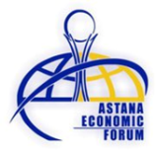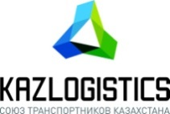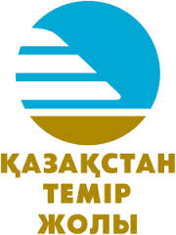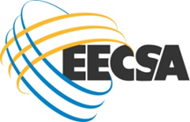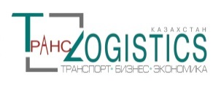

 | May 21, Wednesday
9.00-10.00 | Registration of participants of the panel session («Palace of Independence»)
Museum Hall, Palace of Independence, 3rd floor

Moderator: Andrey Timofeev - Partner and Managing Director of BCG, a member of the Economic Council under the President of the Russian Federation

10.00-10.05 | Official Opening Panel session  Salutary speech of Askar Mamin - Chairman of the Union of Transport of Kazakhstan «KAZLOGISTICS» - President of «National Company «Kazakhstan temir zholy» JSC
10.05-10.15 | «Realization of transit potential of the Republic of Kazakhstan in the context of new strategy of «National Company «Kazakhstan temir zholy» JSC  Askar Mamin - Chairman of the Union of Transport of Kazakhstan «KAZLOGISTICS» - President of «National Company «Kazakhstan temir zholy» JSC
10.15-10.25 | «The New Silk Road - connecting Kazakhstan»  Mohammed Sharaf - Group Chief Executive Officer of DP World
10.25-10.35 | «Integration processes and prospects for transport development within the framework of the Eurasian Economic Community»  Yerzhan Nurakhmetov - Acting Director of Department of Transport and Infrastructure of Eurasian Economic Commission
10.35-10.45 | «Improving logistics performance in the Eurasian transport corridor»  Maria Claudia Pachon - Sr. Transport Specialist Europe and Central Asia of World Bank
10.45-10.55 | «Prospects of air hub development between Europe and Asia»  Thomas Niehaus - Associate Partner, Lufthansa Consulting
10.55-11.05 | «Chongqing - Xinjiang - Europe: connecting Europe and China»  Young Lichong - Deputy Director of the Committee on Economics and Information of Chongqing
11.05-11.45 | Coffee Break
11.45-11.55 | «Forthcoming accession of China to the TIR Convention - an opportunity for economies throughout Silk Road»  Marek Retelski - Head of TIR and Trade Facilitation of the International Road Transport Union (IRU)
11.55-12.05 | «Historical importance of the New Silk Way for Japan and the opportunities that the route open today»  Takuya Ichihashi - Chief Representative of Toyota Tsusho Corporation in Kazakhstan and Central Asia
12.05-12.15 | «The revival of the New Silk Road»  Henry Christensen – Chairman of China Logistics Club
12.15-12.25 | «Business participation in the organization and development of freight wagon and container transport by rail in the direction of China-Kazakhstan-Europe and backward»  Larisa Smirnova - Member of the Supervisory Board of the Association of National Freight Forwarders of Kazakhstan
12.25-12.35 | «Practical aspects of the revival of Great Silk Road»  Eduard Kaplan – Chairman of the Board of ENRC Logistics
12.35-12.45 | «The role of «National Company «Kazakhstan temir zholy» JSC in the development of transport and logistics system of the country»  Darryl Hadaway – Executive Director of «KTZ Express» JSC
12.45-13.00 | Discussion
13.00-13.20 | Summary of Panel session  «Transport infrastructure development - necessary condition of sustainable economic growth of the Eurasian Space»  Andrey Timofeev, moderator - Partner and Managing Director of BCG, a member of the Economic Council under the President of the Russian Federation
13.20-13.30 | Closing Panel session

